Horse name: __________________________ Owner Name: ___________________
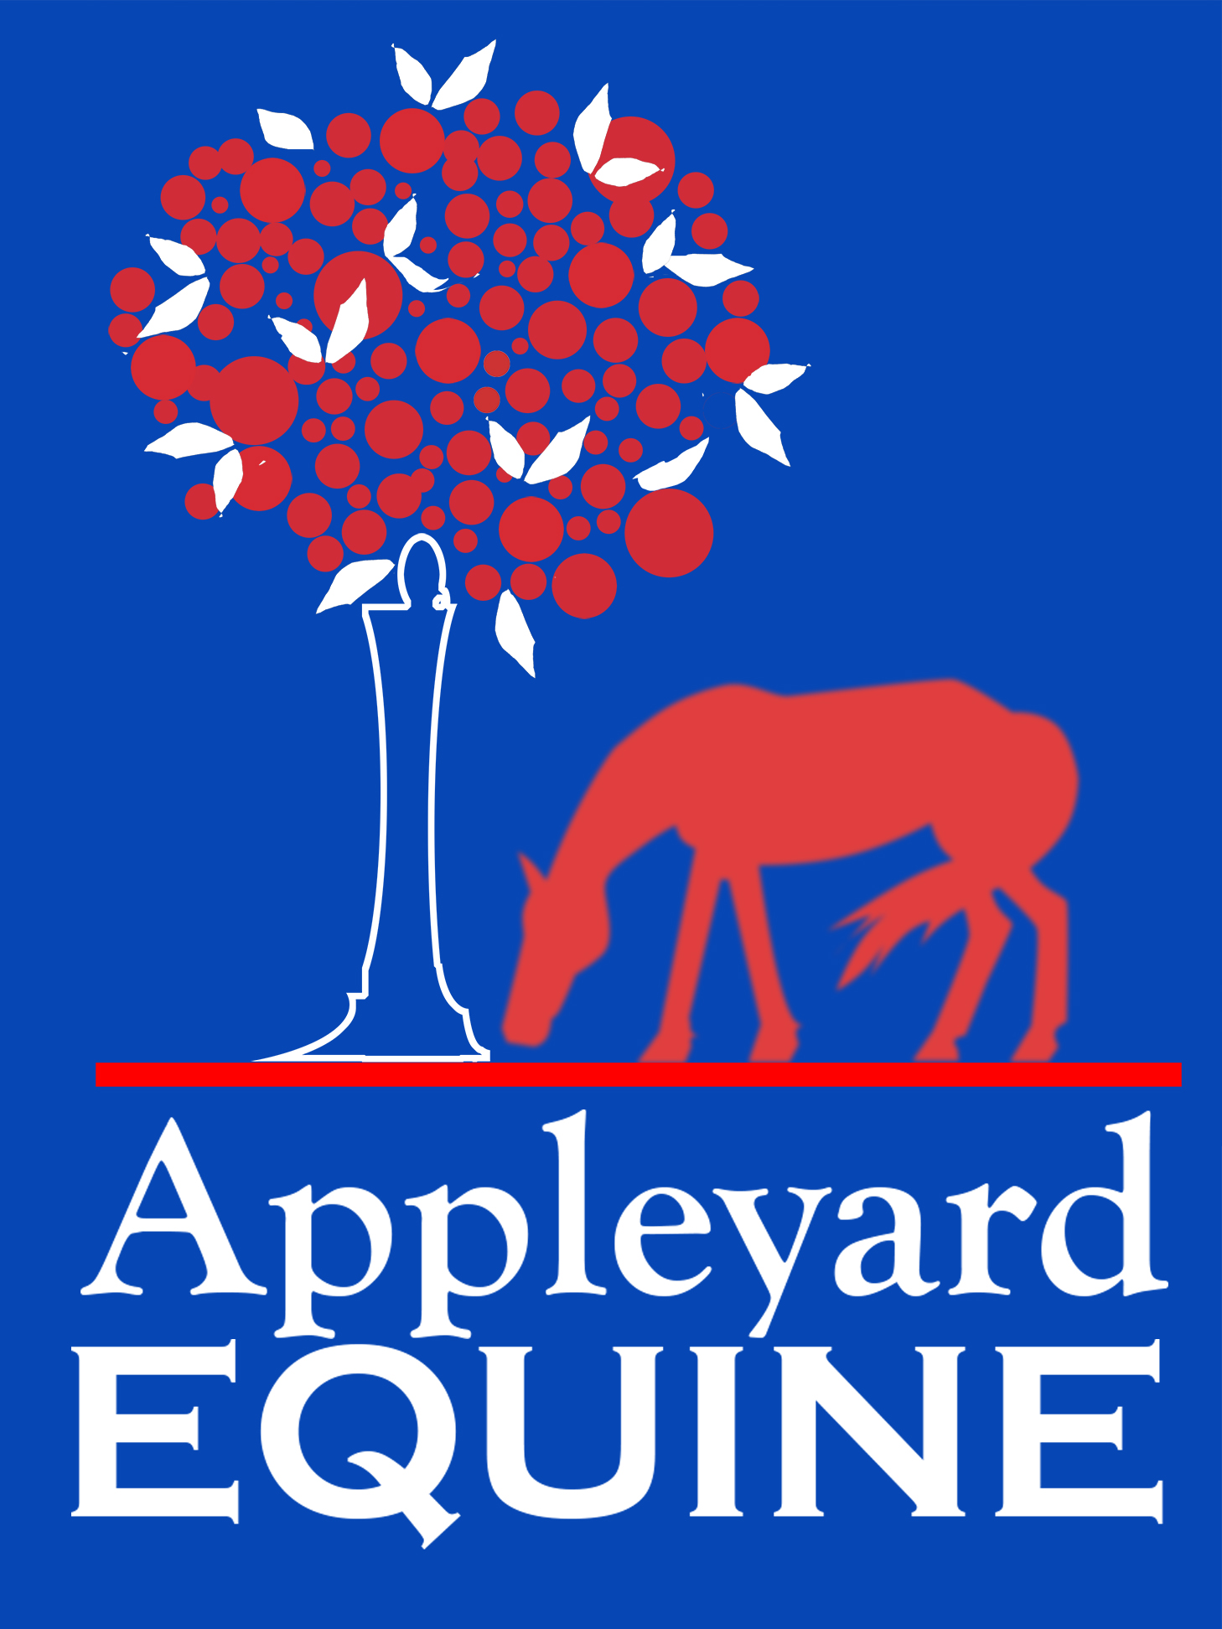
Barn Name: __________________________ BREED: __________________________
Gender/Age: __________________________ Height/ Weight: ________________
When and from where did you acquire this horse?
Current Veterinarian or Hospital:
Any notable long- or short-term health issues, injuries, or behavioral concerns? Have they been resolved?

What is the horse’s current feeding program (including medications, nutraceuticals, and/or supplements)?

Please describe your horse’s living situation (stall, turnout- how many hours, group or solo, etc.).

When was the last time your horse was seen by a vet and why?

Who is your farrier and how often does s/he work on your horse?

What is your horse’s current training or conditioning program, and by how many people is s/he ridden?

Other than your vet, is your horse under the care of any other equine healthcare professional(s), such as an acupuncturist, chiropractor, homeopath, other bodyworker, etc.?

What are your goals for your horse (e.g. in training, competing, health, etc.)?

Is this session intended as part of your horse’s well-being protocol or do you have specific concerns and areas you would like to address?

Any other pertinent information I need to know (history/change in saddle used/lameness/areas of tension or strong behavioral reactions?

